2

***Timestables***

*Each week you will be set a session on Timestables Rockstars for you to complete. This is 10 minutes worth of learning.*

***Reading***

*Please record your daily reading clearly in your reading record.*

***Anglo-Saxons***



**Shakespeare Summer 1**

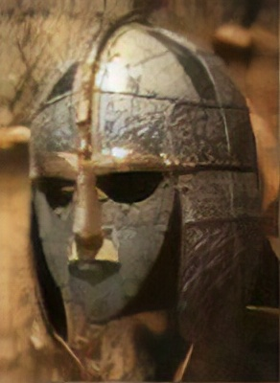

**English We will be learning to:**

* Write a narrative in the style of Beowulf
* Write a newspaper report based on our class text *Beowulf*
* Continue to practise our SPAG and reading comprehension skills

**Science We will be learning to:**

* Explain how we see
* Discover if light can bend and change direction
* Experiment with shadow making and shadow puppets

**RE We will be learning to:**

* Explore what leading a ‘good’ life means to a Muslim
* Discover what Muslims believe about life after death
* Question whether belief in life after death encourages Muslims to live a ‘good’ life

***Writing***

*Each week you will receive a writing-based task to complete and stick in your book. It will take the form of one of the following:*

* *Editing task*
* *Creative writing*
* *Spelling, punctuation and grammar task*
* *Arithmetic task*

**Maths We will be learning to:**

* Revise our work on number, place value and calculation
* Practise our use of fractions, decimals and percentages
* Calculate duration and use timetables

**This term’s spelling patterns to practise:**

**This term’s spelling patterns to practise:**

|  |  |  |
| --- | --- | --- |
| **Week 1**  **ei and ie**  Do of these words follow the pattern: i before e except after c?  receive  mischievous  ceiling  protein  niece | **Week 2**  ***Words ending -ible and -able***  How can you tell when to us an ‘ible’ or ‘able’ ending?  understandable  responsible  comfortable  reliable  invisible | **Week 3**  ***Plural nouns (1)***  How can you tell whether to add ‘es’ or ‘ies’ to a noun?  parties  sketches  opportunities  dictionaries  suffixes |
| **Week 4**  **Plural nouns (2)**  How can you tell whether to add ‘ves’ or ‘oes’ to a noun?  mosquitoes  calves  buffaloes  bookshelves  tornadoes | **Week 6**  **Hyphenated words**  Why do these words need to be hyphenated?  co-operate  man-eating  re-explain  co-ordinate  mother-in-law |  |

**Topic We will be learning to:**

* Describe where, when and why the Anglo-Saxons invaded Britain
* Explain the impact that the monk Augustine has on the spread of Christianity
* Evaluate the impacts of kings Offa, Ethelred the Unready and Cnut

**Please RETURN THE HOME LEARNING BOOK EVERY MONDAY.**

Please note that there are no spellings during SATS Week – week 5 of term