f

Write or tell someone a story as if you were at The great fire of London. See if you can include some key facts

Do a selfless act for someone else

Create a Tudor house (This will be burnt so please make using cardboard) By 9th Dec

***Weekly Home Learning***

*Please record your* ***daily reading*** *in the diary, practise your* ***spellings*** *and RockStars* ***timetables****. You can also complete one of the optional activities below:*

***Snap Crackle Pop***

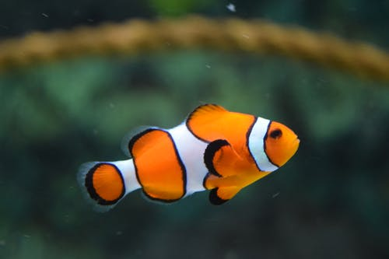



**Blake Class**

**Term 5**

|  |  |  |
| --- | --- | --- |
| **Week 1**  Out  Shout  About  Ouch  Found  The  Today  Said  Says  Are | **Week 2**  Blow  Snow  Throw  Yellow  Show  Were  Was  Has  You  Your | **Week 3**  Fair  Hair  Hairy  Pair  Chair  They  By  My  Here  There |
| **Week 4**  Start  Car  Large  Hard  Sharp  Where  Love  Come  Some  One | **Week 5**  Door  Floor  Short  Storm  Sport  Once  Ask  Friend  School  Put | **Week 6**  First  Girl  Shirt  Bird  Thirsty  Push  Pull  Full  House  Our |

Make a poster/leaflet to make people aware of the dangers of fire

Explain to a member of your family how to multiply or divide a number

**History We will be learning:**

* About The Great Fire of London
* About the 1600’s
* Samuel Pepys Diary

**RE We will be learning about Christianity**

* Explore the bible stories of Jesus showing kindness
* Story of Zacchaeus

Identify a variety of materials around your home.

**Please RETURN THE HOME LEARNING BOOK EVERY MONDAY, even if you have not completed an optional task.**

**The children will be completing their spelling and tables’ tests in the books so you can see how they have done when they are returned on Wednesday.**

**Science We will be learning:**

* To identify a variety of materials
* To alter the shape of a solid.
* About John Dunlop and Charles Macintosh

**Maths We will be learning to:**

* Develop our times tables 2, 3, 4, 5, 8, 10
* Counting from any number in multiples of 2, 3, 4, 5, 8, 50 and 100
* Multiply and divide, using formal written methods (2digit x 1 digit)

**English We will be learning to:**

* Write diary entries
* Create a news report
* Use rhyme and alliteration in poems